APL 104 Project

Identifying linear elastic constants of a 2D Linear elastic Plate

Group members –

Raghav Narang, 2023AM11165

Rishit Singh, 2023AM11036

Index

1. Derivation of governing equations Pg 2…3
2. Parameter Identification methodology Pg 4 …17
3. Results Pg 17 …25

Derivation of governing Equations

In the case of linear elastic isotropic materials, the 15 equations of elasticity can be reduced to just 3 governing equations known as the Navier’s elasticity equations.

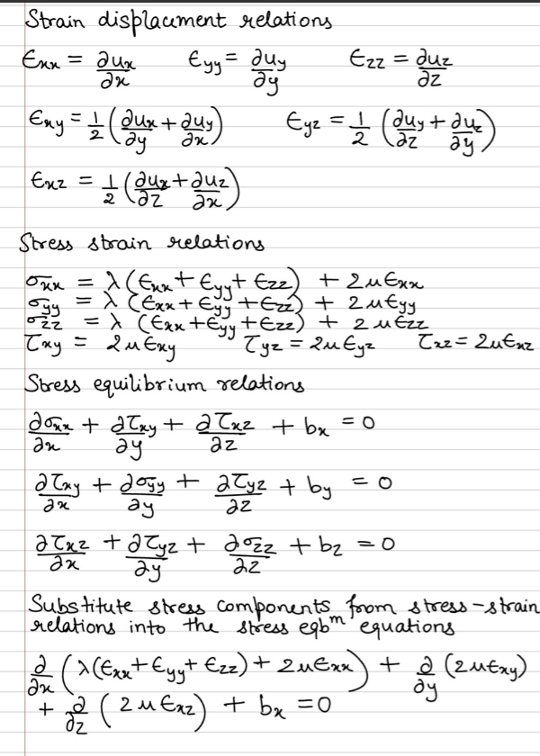

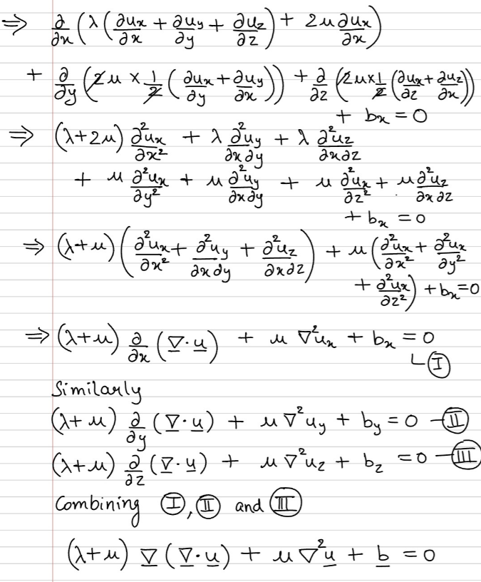

Parameter Identification Methodology

In order to obtain the Lame’s constants, we tried out two methods. When we hit a roadblock with the first approach we went onto the second approach.

**Approach - 1**

Consider displacement data set 1. We try to find a general expression for ux and uy in terms of x and y. To do so we have built a neural network model and a polynomial regression model which fit the best curves to the given data.

In the polynomial regression model, we observe that as we increase the degree of the polynomial the error between the predicted and given values of ux and uy decreases. However, with increasing degree overfitting is also becoming a problem. That’s where the neural network model comes in.

Neural network avoids overfitting while modelling a data set. So, we note the error between the predicted and test data generated by the neural network, and check that this value of error lies between the errors produced by which two degrees of polynomial regression model. This way we obtain an optimal fit to our displacement data while avoiding overfitting.

We find that both ux and uy are degree 5 polynomials. Once we have obtained the expressions for ux and uy, we can find the general expressions for the corresponding strains Єxx, Єyy and Єxy, using the following strain displacement relations.

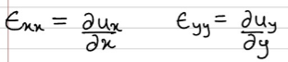 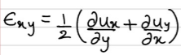

Now we apply the stress strain relations to obtain stresses σxx, σyy and τxy in terms of the Lame’s constants λ and µ.

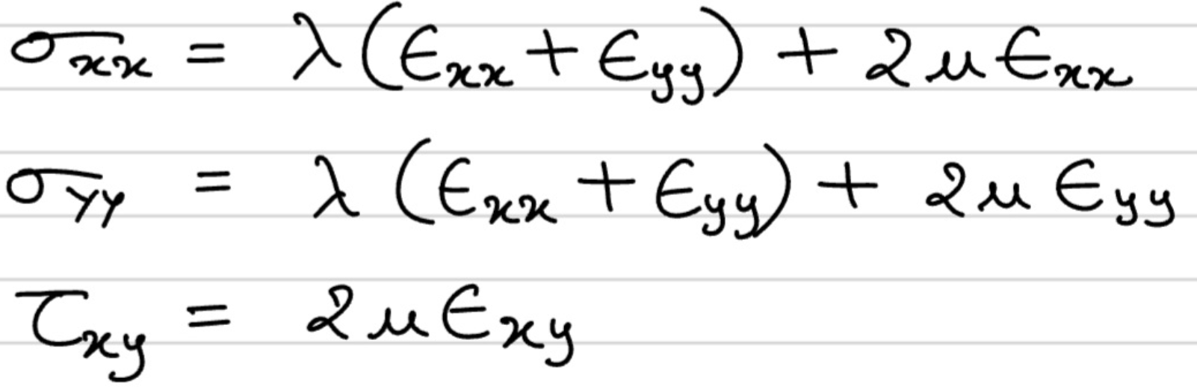

Now we apply the boundary conditions by making use of the reactions given to us on the edges as –

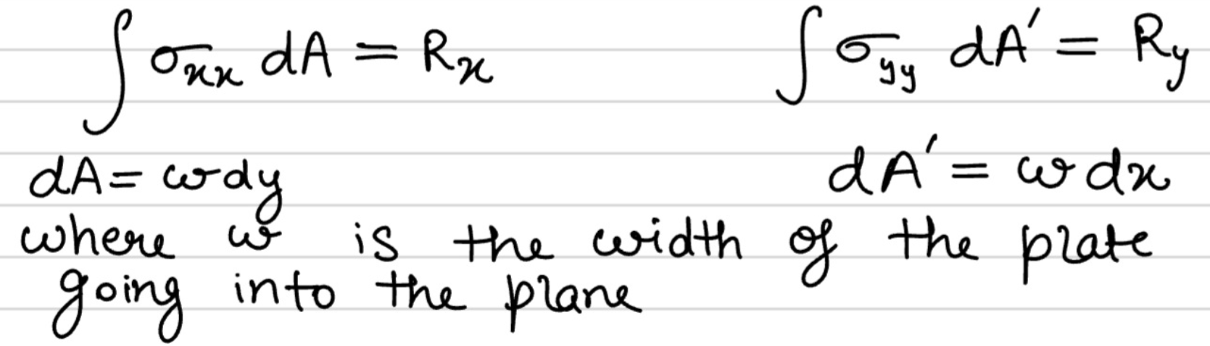

This will give us two equations in λ and µ which we can solve to obtain the values of the Lame’s constants.

Once we have our Lame’s constants we can write the general expression for the stresses and use them to make plots illustrating the distribution of stresses and strains in the plate.

This process has to be repeated for each displacement step to obtain general expressions of displacements, strains and stresses followed by their plots.

**Calculations**

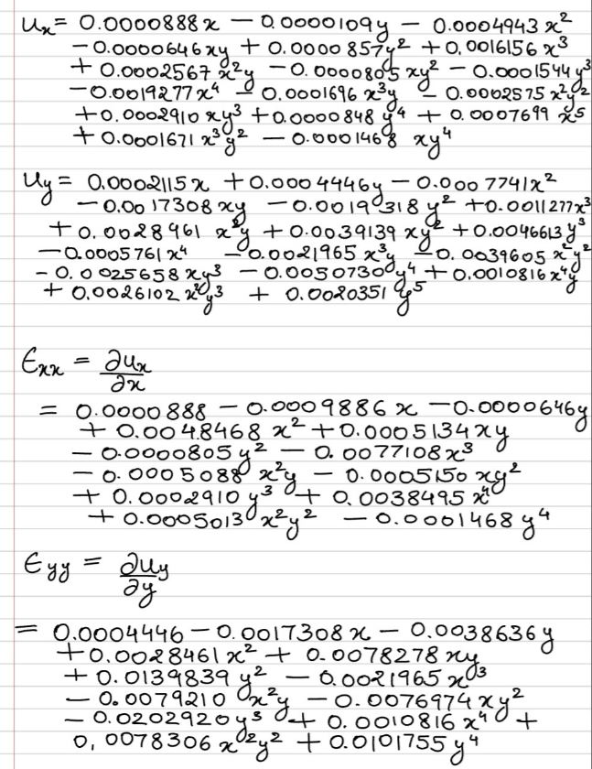

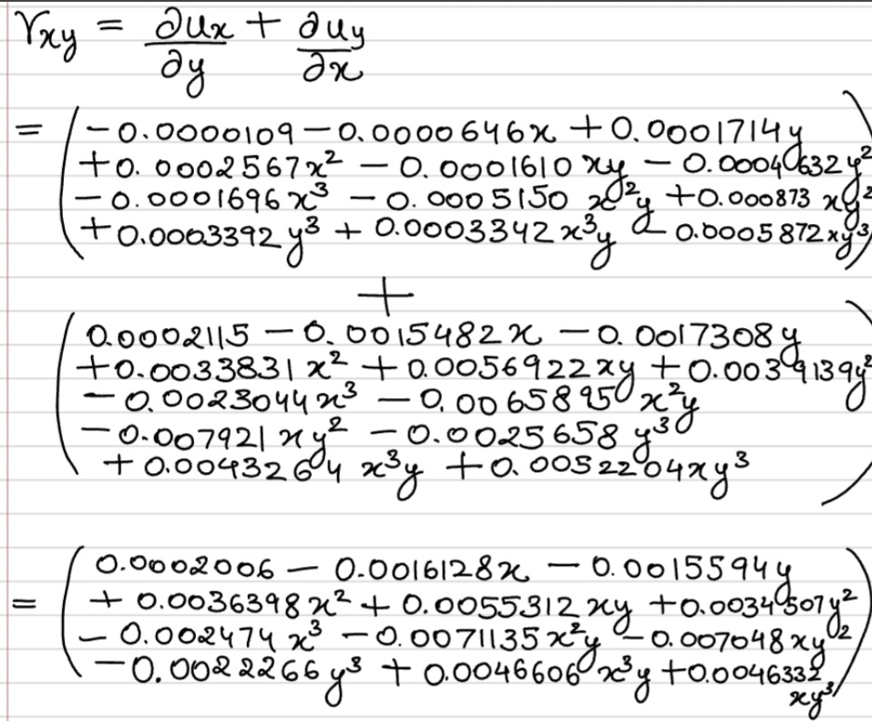

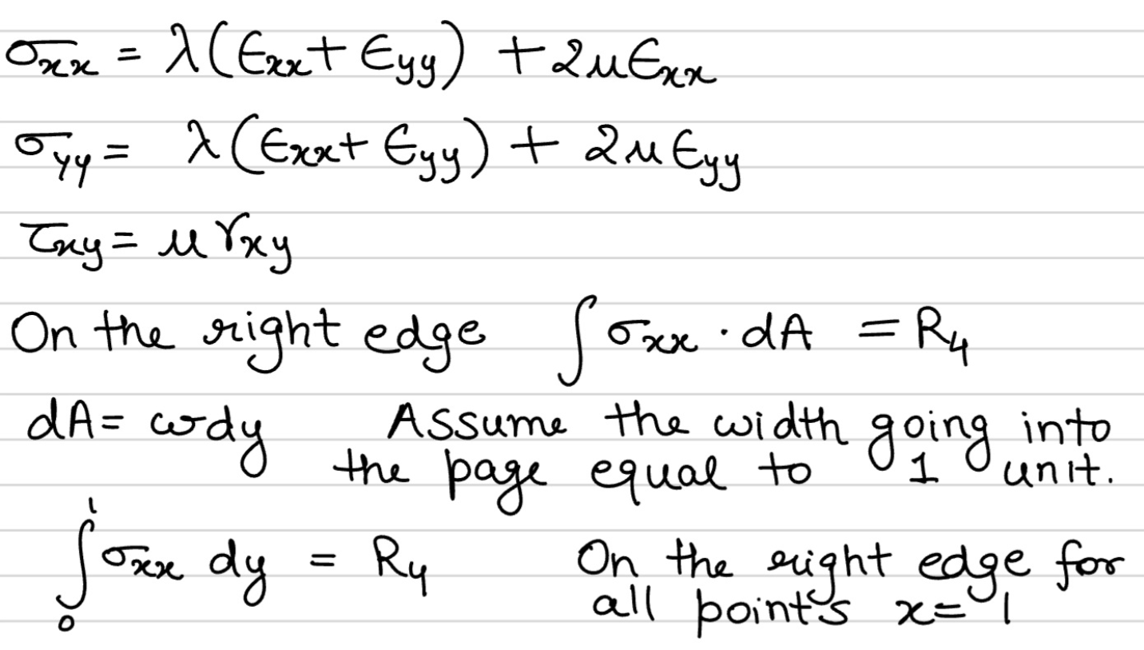

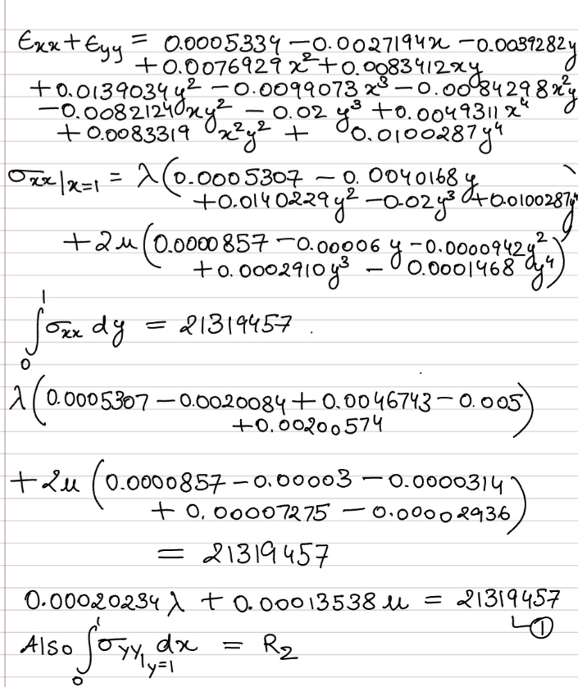

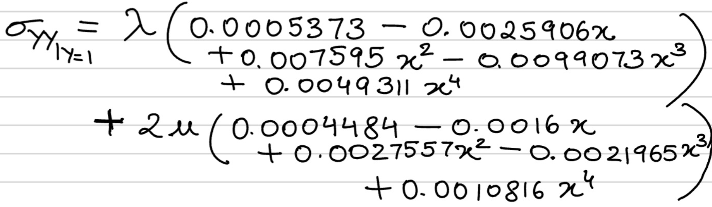

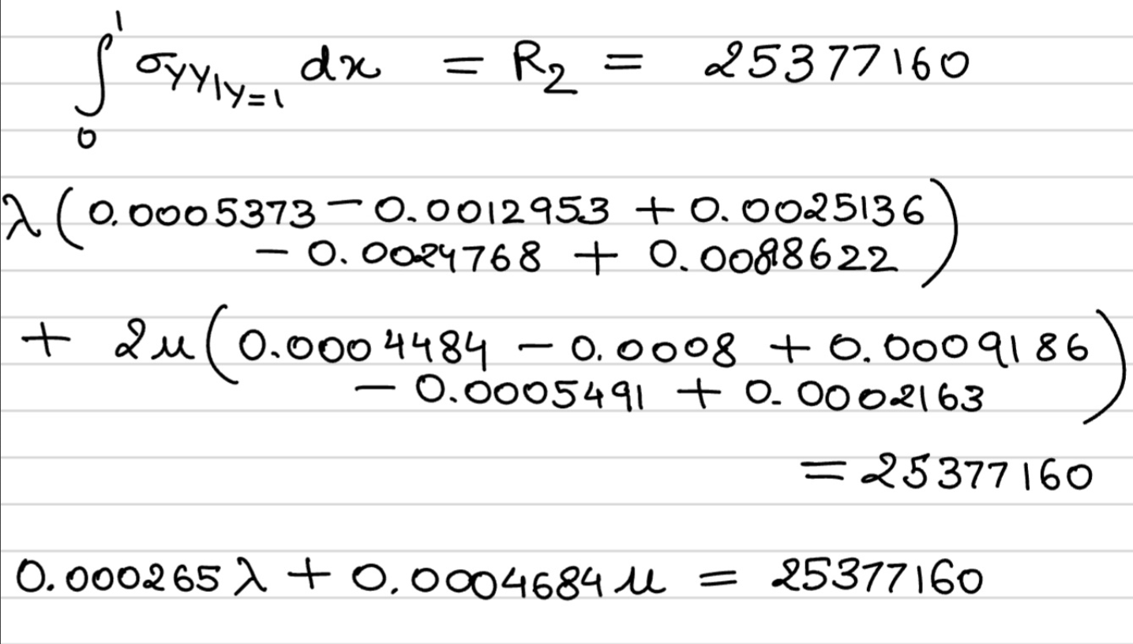

The above two equations in λ and µ, yield

λ = 1.11 * 1011 Pa, µ = -8.7 * 109 Pa

Since shear modulus of any material cannot be negative, this is clearly wrong. Such an inadmissible result appears probably because we have not accommodated for the elliptical hole in the plate in our procedure.

Hence, we had to try out a different approach as follows.

**Approach 2**

In order to accommodate for the elliptical hole in the plate, we divide our domain into pieces. The ellipse lies in the region x = (0.3, 0.7) and y = (0.4,0.6). So, we divide the domain into 9 regions –

x = (0, 0.3) ; y = (0, 0.4) x = (0, 0.3) ; y = (0.4, 0.7) x = (0, 0.3) ; y = (0.7, 1)

x = (0.3, 0.7) ; y = (0, 0.4) x = (0.3, 0.7) ; y = (0.4, 0.7) x = (0.3, 0.7) ; y = (0.7, 1)

x = (0.7, 1) ; y = (0, 0.4) x = (0.7, 1) ; y = (0.4, 0.7) x = (0.7, 1) ; y = (0.7, 1)

In each of these regions, we try to find general expressions for the displacements ux and uy. In each region of the domain, we observe the variation of ux and uy with x, keeping y constant and then the variation of ux and uy with y, keeping x constant. This gives us a basic idea of what kinds of curves we would have to fit using regression models to obtain an expression for ux and uy.

We observe that ux v/s y and uy v/s x curves are like Gaussian Bell curves, and hence use a combination of exponential and polynomial regression to model ux and uy in each region.

This yields us a piece wise continuous function for the displacements ux and uy. The following method remains the same, where we use strain displacement relations to compute the strains, followed by using the stress strain relations to obtain stresses in terms of the Lame’s constants. Then we apply the boundary conditions where we integrate normal stresses on the boundaries of the plate and equate them to the corresponding reactions to obtain the values of the Lame’s constants.

Furthermore, in the region close to the ellipse, it is interesting to observe that the gradient of u_y wrt y is proportional to the length of the vertical chord of the elliptical hole at the given fixed x. however the variation is linear away from the hole

The same being said, the variation of u_x wrt to y at fairly constant x was observed to follow a gaussian double bell curve function due to the elliptical thickness being smaller in the y direction hence development of two maximas.

Hence the variation in the middle portion close to the ellipse follows the same rule as in u_y and the outer portions is linear

All the estimation and fitting of variations has been done using the scipy curve fitting after starting with a calculated guess on the type of function, based on the graph plots through matplotlib. All this is included in the python notebook.

Having deduced the Lame’s constants, we can write general expressions for stresses and plot heat maps from them.

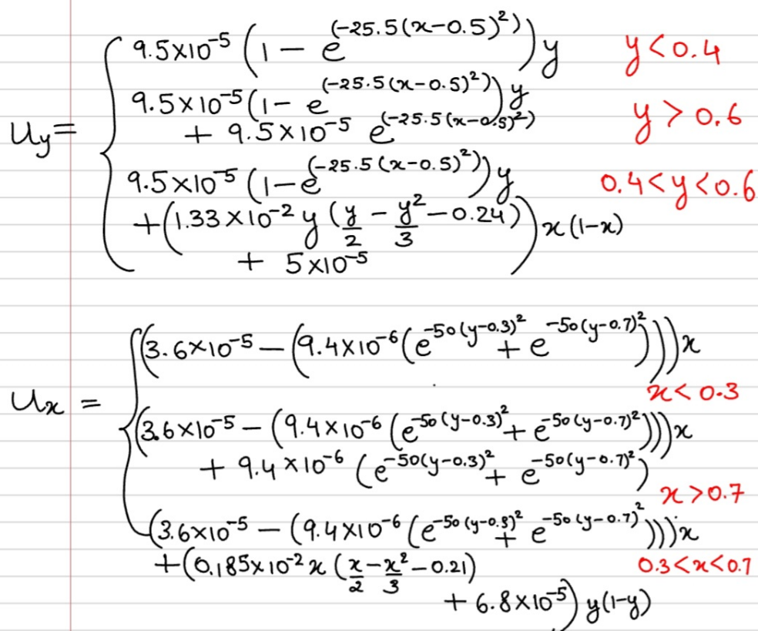

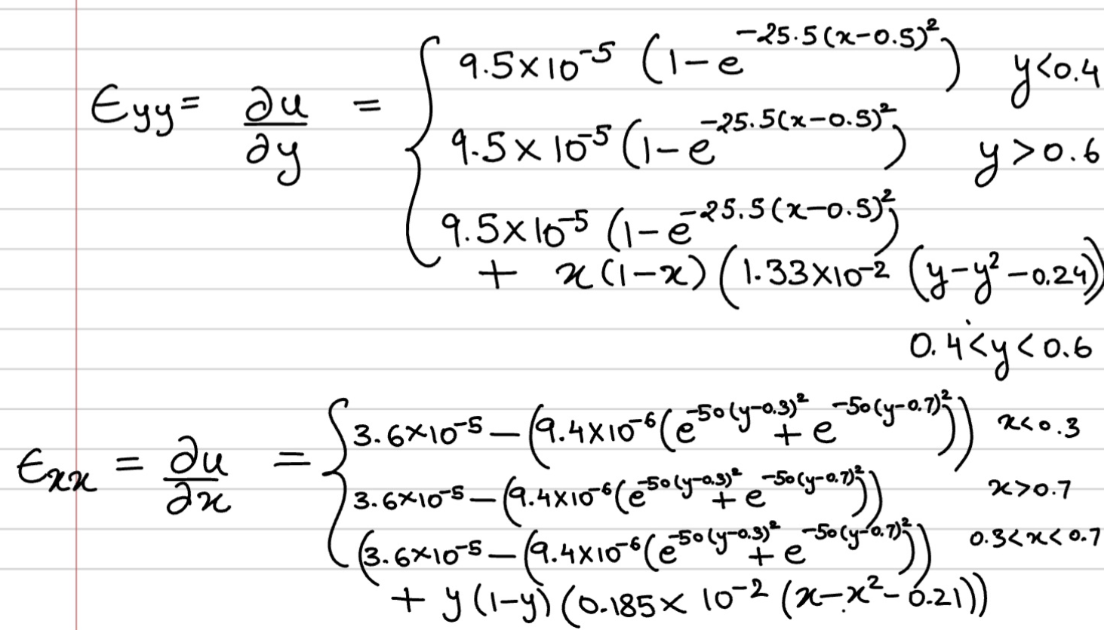

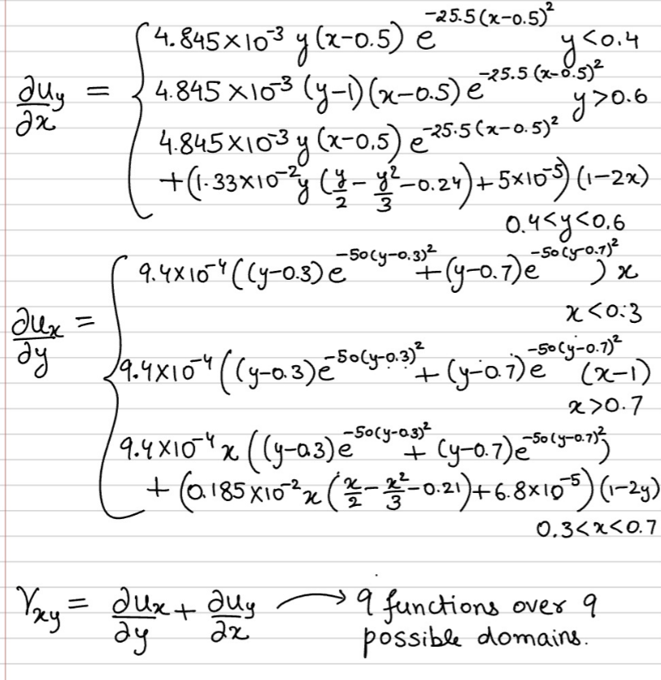

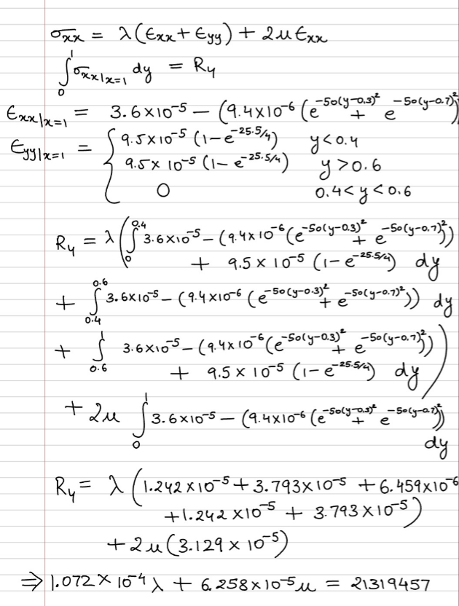

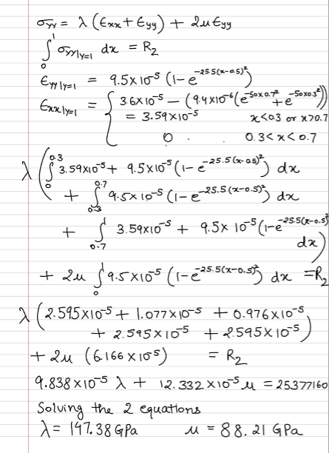

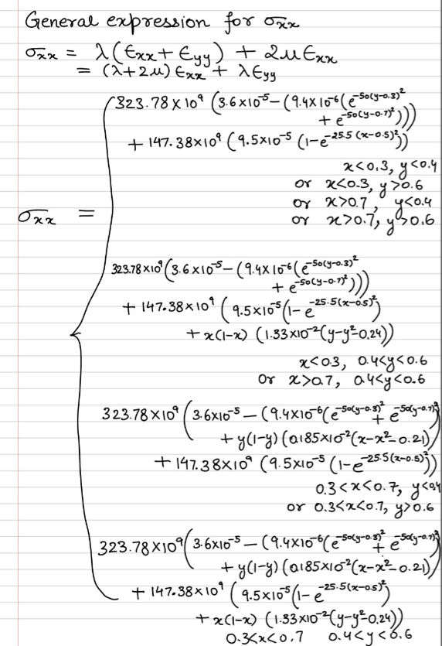

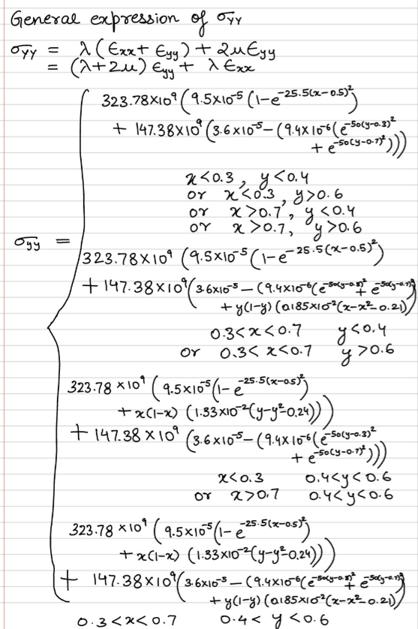

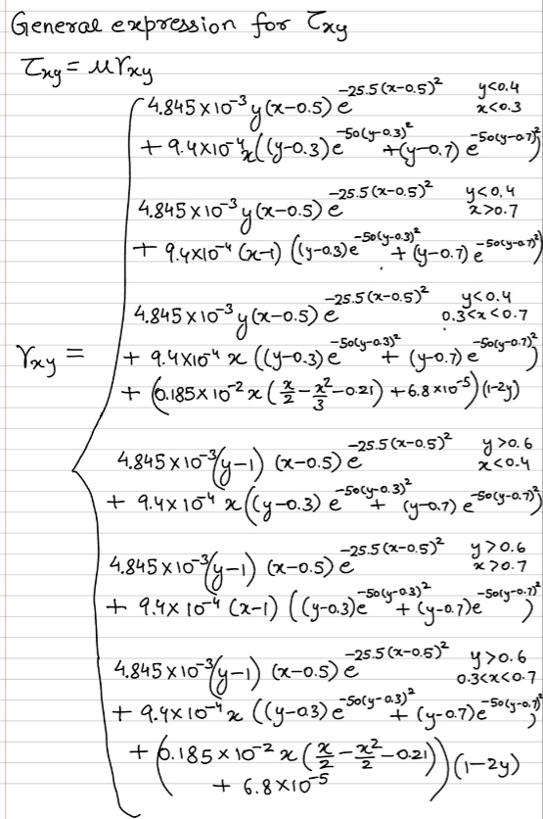

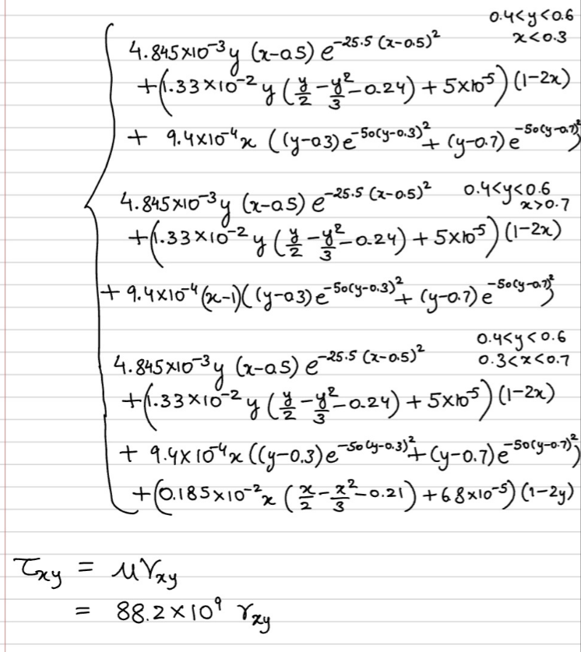

Results

λ = 147.38 GPa µ = 88.2 GPa

Heat map for first loading step –

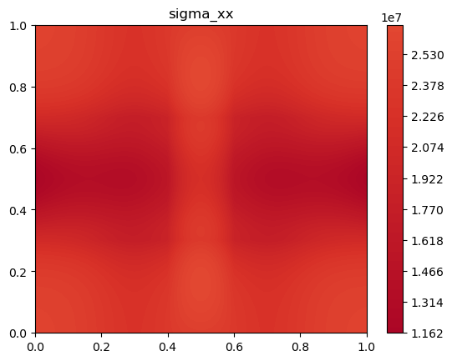

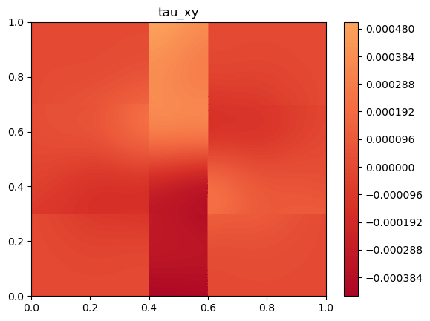

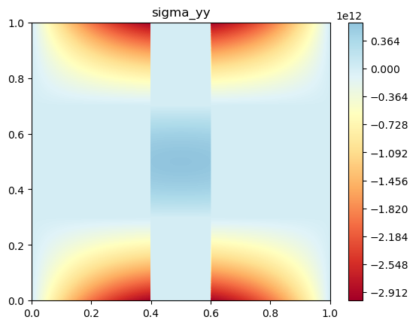

Heat map for second loading step –

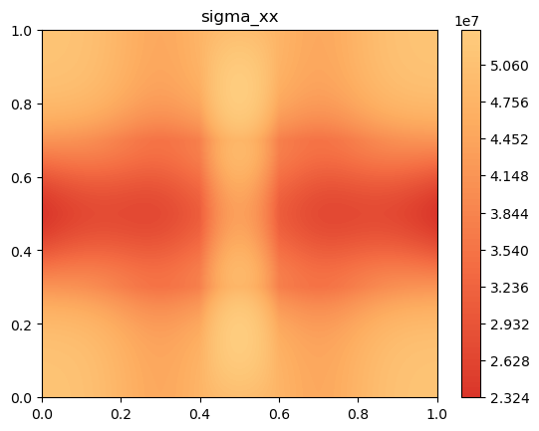

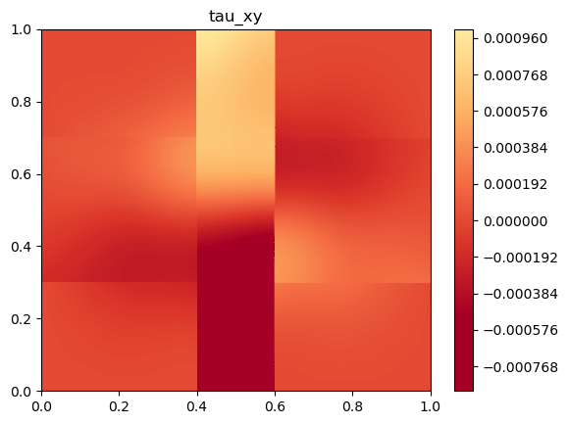

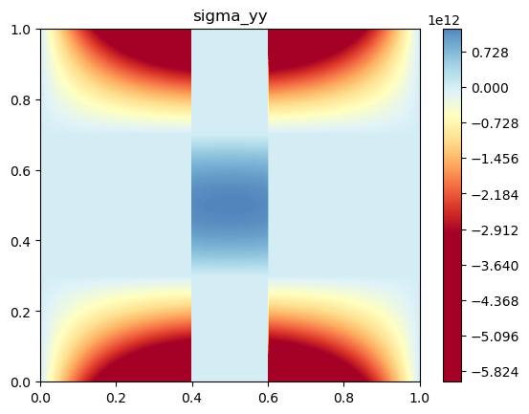

Heat map for third loading step –

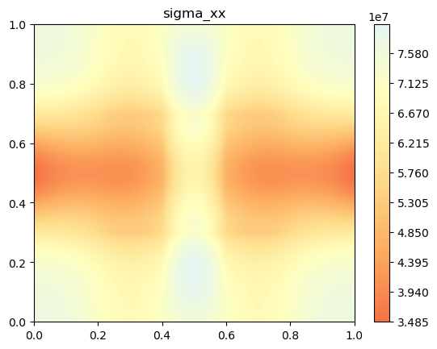

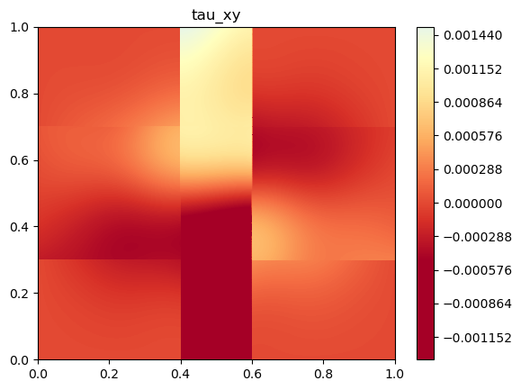

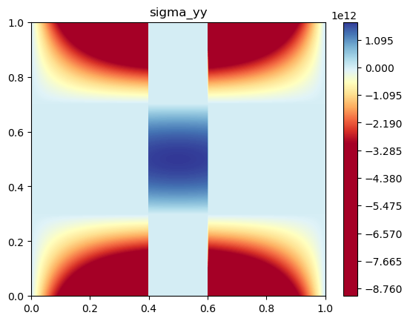

Heat map for fourth loading step –

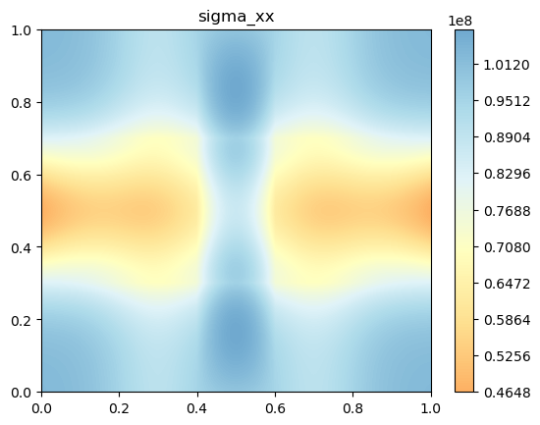

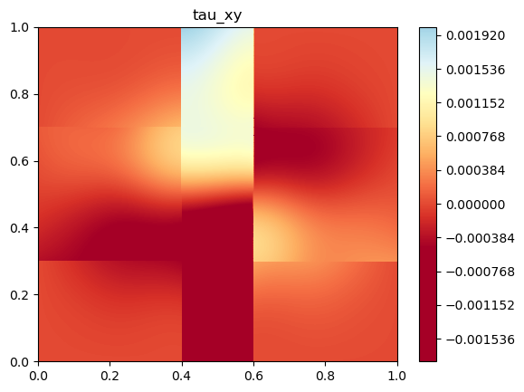

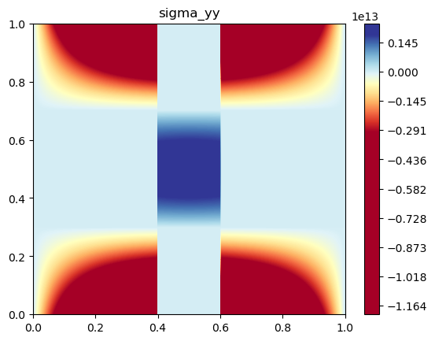

Heat map for fifth loading step

